PROJECT REPORT

Sales Data Analysis & Visualization Using R

1. Introduction
In today’s data-driven world, data visualization plays a vital role in transforming raw data into meaningful insights. R is a powerful statistical programming language widely used for data analysis and visualization.
This project focuses on analyzing and visualizing sales data using R and RStudio. Multiple visualization techniques—ranging from basic charts to advanced analytical plots—are implemented to understand sales performance across categories, regions, customer types, and time.

2. Objectives of the Project
The primary objectives of this project are:
- To import and preprocess a real-world-like sales dataset in R
- To perform data aggregation and summarization using dplyr
- To visualize sales trends, distributions, and comparisons using ggplot2
- To implement advanced visualizations such as heatmaps, funnel charts, and forest plots
- To derive meaningful business insights from sales data

3. Tools and Technologies Used
Tool / Library | Description
R | Statistical programming language
RStudio | Integrated Development Environment
ggplot2 | Data visualization
dplyr | Data manipulation
tidyr | Data reshaping and tidying
lubridate | Date and time handling
scales | Axis and number formatting

4. Dataset Description
The dataset used in this project is a CSV file selected by the user at runtime using file.choose().

Dataset Attributes:
Column Name | Description
Order_ID | Unique identifier for each order
Order_Date | Date and time when the order was placed
Region | Sales region (North, South, East, West)
Category | Product category
Sales | Sales amount
Quantity | Number of items sold
Customer_Type | New or Returning customer
The dataset contains transactional sales records suitable for time-based and categorical analysis.

5. Data Loading and Preprocessing
The dataset was loaded into R using the read.csv() function. Manual file selection was enabled using file.choose() for flexibility.

Preprocessing Steps:
- Imported CSV data into R
- Inspected data structure using head() and str()
- Converted Order_Date into POSIXct format for accurate time-based analysis
These steps ensured the dataset was clean and ready for visualization.

6. Data Visualization and Analysis

6.1 Total Sales by Category (Bar Chart)
A bar chart was created to visualize total sales across different product categories.
Sales values were aggregated using stat_summary(fun = sum).
Code:
# 1. Total Sales by Category (Bar Chart)
ggplot(data, aes(x= Category, y= Sales, fill = Category)) +
stat_summary(fun = sum, geom = "bar") +
labs(title = "Total Sales by Category",
x= "Category",
y= "Sales") +
theme_minimal()
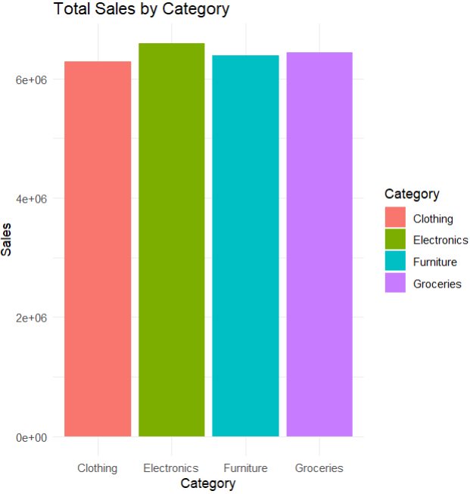
Insight:
This chart helps identify which product categories contribute the most to overall revenue.

6.2 Daily Sales Trend (Line Chart)
Sales data was grouped by date to analyze daily sales performance over time. A line chart was used to visualize trends and fluctuations.
Code:
# 2. Sales Trend Over Time (Line Chart)
# Step 1: Aggregate the data
daily_sales <- data %>%
group_by(as.Date(Order_Date)) %>%
summarise(Total_Sales = sum(Sales))

# Step 2: Create Line Chart
ggplot(daily_sales, aes(x = `as.Date(Order_Date)`, y = Total_Sales)) +
geom_line(color = "green") +
labs(title = "Daily Sales Trend",
x = "Date",
y = "Sales") +
theme_minimal()
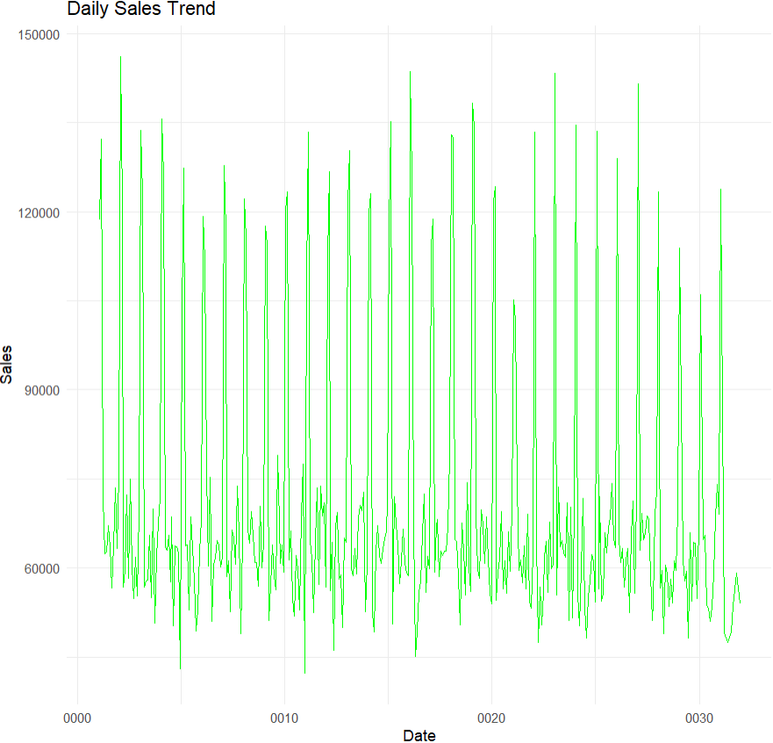
Insight:
The visualization highlights daily variations in sales and helps identify growth patterns and seasonal behavior.

6.3 Sales Distribution by Category (Box Plot)
A box plot was used to analyze sales distribution and variability across categories.
Code:
# 3. Sales Distribution (Box Plot)
ggplot(data,aes(x = Category, y = Sales, fill = Category)) +
geom_boxplot() +
labs(title = "Sales Distribution By Category") +
theme_minimal()
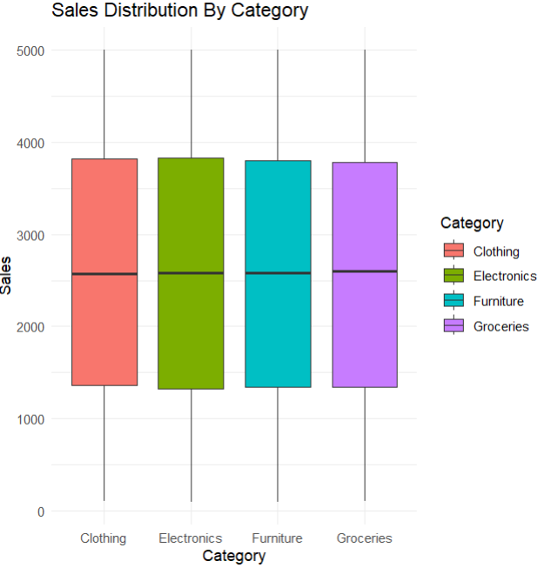
Insight:
This chart helps identify outliers, spread, and median sales values for each category.

6.4 Total Sales by Region (Bar Chart)
A regional sales comparison was created using a bar chart that displays total sales per region.
Code:
# 4. Sales By Region (Bar Chart)
ggplot(data, aes(x = Region,y = Sales, fill = Region)) +
stat_summary(fun = sum, geom = "bar") +
labs(title = "Total Sales By Region") +
theme_minimal()
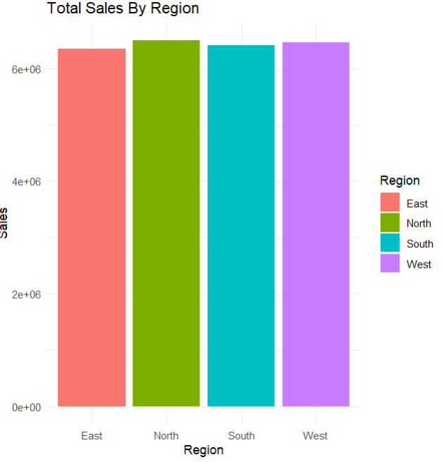
Insight:
This visualization reveals region-wise sales performance and identifies high-performing regions.

6.5 Average Sales by Customer Type (Bar Chart)
A bar chart was used to compare average sales between new and returning customers.
Code:
# 5. Customer Type Comparion (Bar Chart)
ggplot(data, aes(x = Customer_Type, y = Sales, fill = Customer_Type)) +
stat_summary(fun = mean, geom = "bar") +
labs(title = "Average Sales By Customer Type") +
theme_minimal()
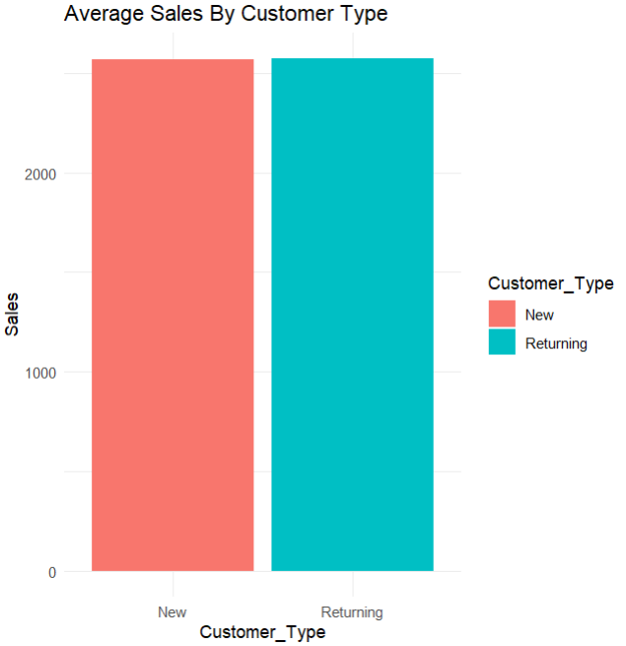
Insight:
The chart highlights customer behavior and spending differences between customer types.

6.6 Heatmap: Sales by Region and Category
A heatmap was created to visualize total sales across region-category combinations using color intensity.
Code:
# 6. Sales By Region & Category (Heatmap)
# Step 1: Aggreagate the data
heatmap_data <- data %>%
group_by(Region,Category) %>%
summarise(Total_Sales = sum(Sales))
# step 2: Create Heatmap
ggplot(heatmap_data, aes(x = Category, y = Region, fill = Total_Sales)) +
geom_tile(color = "white") +
scale_fill_gradient(low = "lightblue", high = "darkblue") +
labs(
title = "Heatmap: Total Sales by Region and Category",
x = "Category",
y = "Region",
fill = "Sales"
) +
theme_minimal()
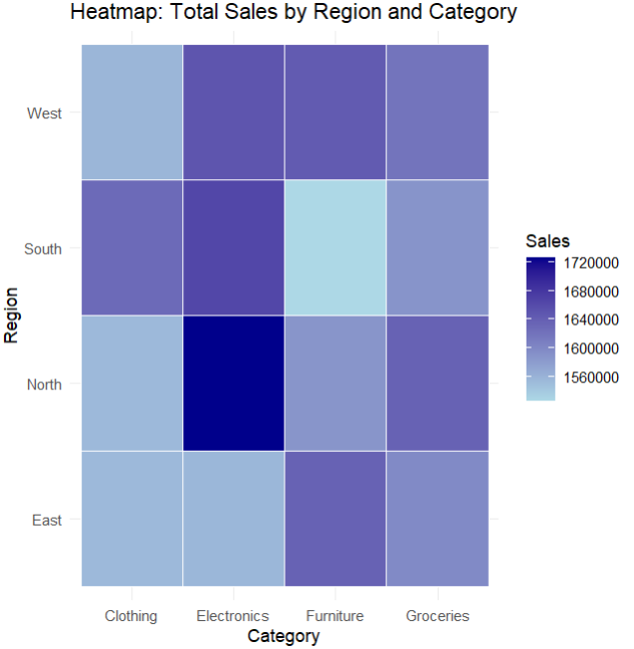
Insight:
The heatmap clearly identifies strong and weak category performance across different regions.

6.7 Funnel Chart: Sales Conversion Flow
A funnel chart was implemented to represent sales conversion stages, including:
- Total orders placed
- Orders with higher quantities
- High-value sales orders
Code:
# 7. Funnel Chart - Sales Conversion Flow
# Step 1: Create Funnel Data
funnel_data <- data.frame(
Stage = c("Orders Placed",
"Orders with Quantity > 2",
"Orders with Sales > 2000"),
Count = c(
nrow(data),
nrow(filter(data, Quantity > 2)),
nrow(filter(data, Sales > 2000))
)
)
# Step 2: Funnel Chart (Using Bar Chart Logic)
ggplot(funnel_data, aes(x = reorder(Stage, -Count), y = Count, fill = Stage)) +
geom_bar(stat = "identity") +
coord_flip() +
labs(
title = "Sales Funnel Analysis",
x = "Stage",
y = "Number of Orders"
) +
theme_minimal()
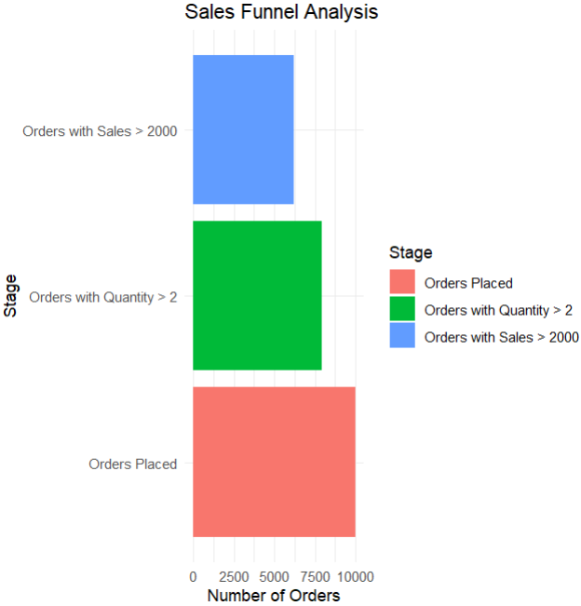
Insight:
This visualization highlights drop-offs at each stage of the sales funnel.

6.8 Forest Plot: Average Sales with Confidence Intervals
A forest plot was created to display average sales by category along with 95% confidence intervals.
Code:
# 8. Forest Plot – Average Sales with Confidence Intervals
# Step 1: Prepare Summary Statistics
forest_data <- data %>%
group_by(Category) %>%
summarise(
Mean_Sales = mean(Sales),
SD = sd(Sales),
N = n()
) %>%
mutate(
Lower = Mean_Sales - 1.96 * (SD / sqrt(N)),
Upper = Mean_Sales + 1.96 * (SD / sqrt(N))
)
# Step 2: Forest Plot
ggplot(forest_data, aes(x = Mean_Sales, y = Category)) +
geom_point(size = 3, color = "blue") +
geom_errorbarh(aes(xmin = Lower, xmax = Upper), height = 0.2) +
labs(
title = "Forest Plot: Average Sales by Category",
x = "Average Sales (with 95% CI)",
y = "Category"
) +
theme_minimal()
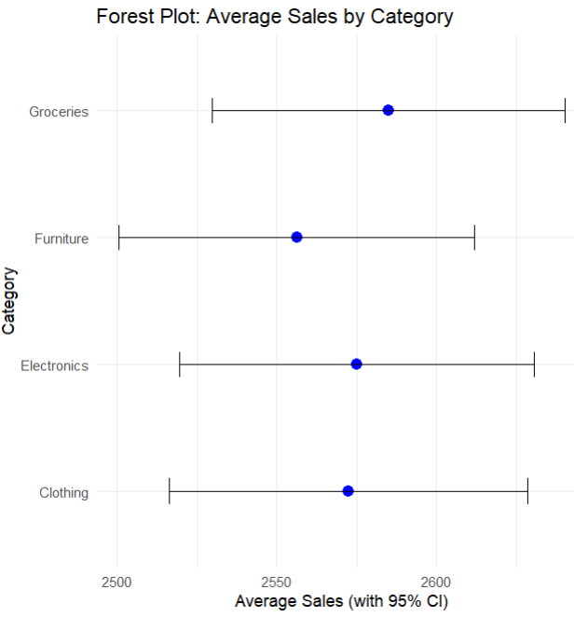
Insight:
This advanced visualization provides a statistical comparison of categories while showing data variability and reliability.

7. Key Learnings
- Gained hands-on experience with R and RStudio
- Learned how to manipulate and summarize large datasets
- Developed multiple data visualization techniques
- Understood how to communicate business insights using charts
- Implemented advanced analytical plots such as heatmaps and forest plots

8. Conclusion
This project successfully demonstrates the use of R for comprehensive data visualization and analysis. By applying various graphical techniques, raw sales data was transformed into meaningful insights that support business decision-making. The project builds a strong foundation for further work in data analytics and business intelligence.

9. Future Scope
The project can be further enhanced by:
- Creating interactive visualizations using Plotly
- Developing dashboards using Shiny
- Applying predictive analytics and forecasting models
- Using real-world enterprise datasets
- Integrating the project with business intelligence tools

10. References
- R Official Documentation
- ggplot2 Documentation
- dplyr Cheat Sheet
- RStudio User Guide

